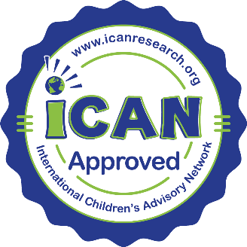
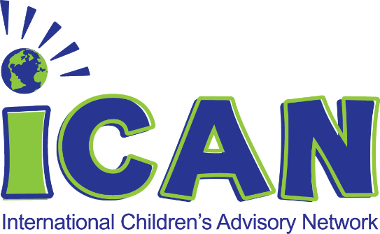

iCAN Seal of Approval Program

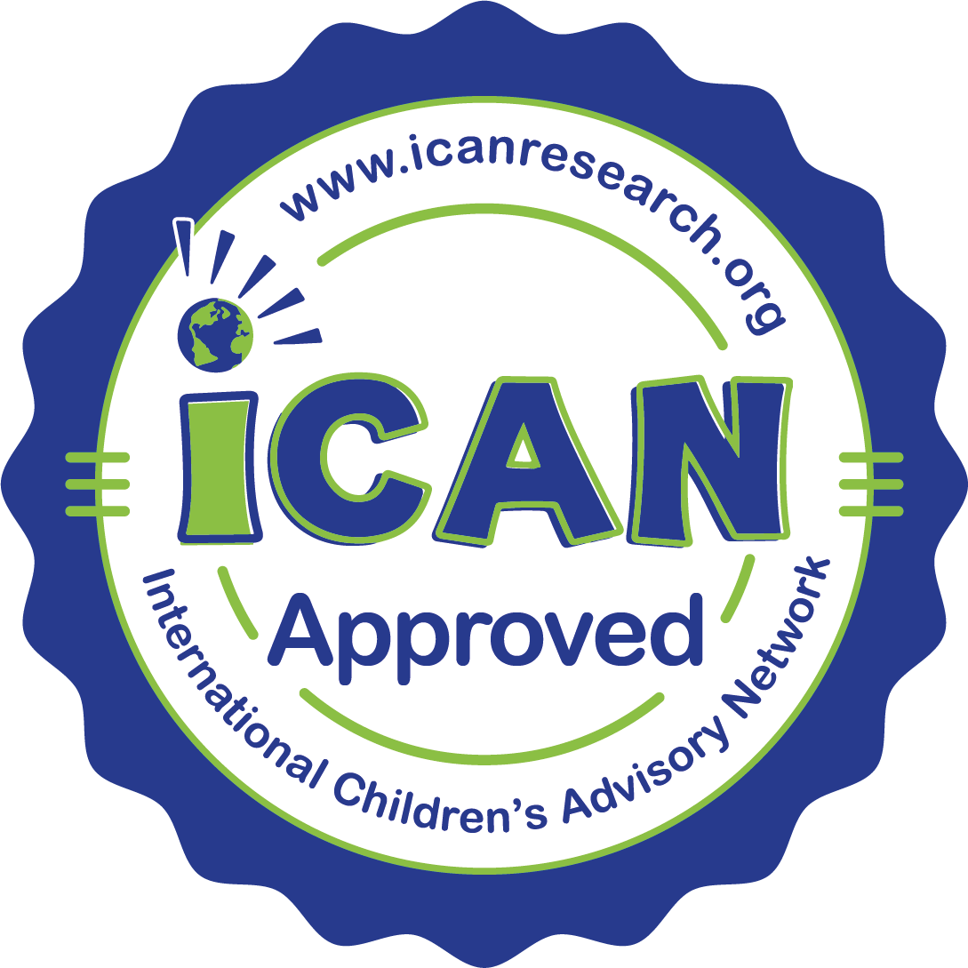
iCAN is a resource available to any organization, company, or group that seeks the input of children and families for their projects and products. When you work with us, you know that your product is iCAN approved and friendly to kids around the world.

Kid Reviewed. Kid Approved.

To show that your product is iCAN approved, you can now add our new iCAN Seal of Approval! After our kids review your material, and you make any recommended changes, your product can proudly display the iCAN Seal Approval.

​

What can be iCAN approved? Clinical trial protocols, consent, assent, educational material, medical devices, and more.

​

When your product is iCAN kid reviewed, you'll know it's age appropriate and favorably accepted by youth. The more you know, the better your product will be.

​

Choose iCAN. Three Easy Steps.
- iCAN kids review your material, and
- You make any kid-recommended changes, then
- Your product can proudly display the iCAN Seal of Approval.*

* Required Acknowledgement: The iCAN Seal of Approval is a trademark of the International Children’s Advisory Network, Inc and signifies that this product has been reviewed by youth to be youth friendly. It does not reflect an endorsement of this clinical product or clinical trial.

To discuss how to give your product the NEW iCAN Seal of Approval,

please email us at info@icanresearch.org​

Disclaimer of Liability: The iCAN Seal of Approval does not endorse nor approve legal, ethical, religious, or political statements, art, or video, nor other subject matter deemed controversial by iCAN. iCAN expressly disclaims any legal liability or responsibility to any and all use of the iCAN Seal of Approval (past, present, or future) including, without limitation, the company, its Board of Directors, and any special committee of board of directors.

