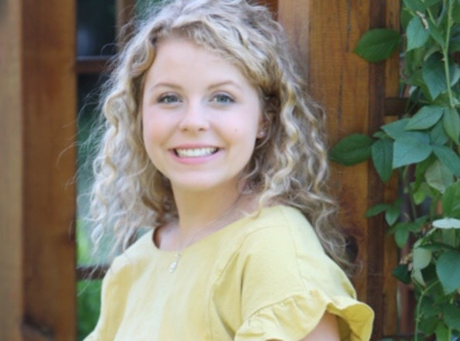
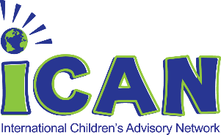
ICAN Make A Difference
Meet Reece Ohmer
Age: 17
Chapter: KIDS Michigan
Joined iCAN: 2014
Future Plans: Fall, 2019 Michigan State University and study psychology, pre-medicine
Favorite iCAN Moment: Meeting other youth members that share the same values in helping other kids around the world at the Summit.

Recently, I was able to participate as a youth representative for International Children’s Advisory Network (iCAN) Research at the Pediatric Trials Network (PTN) Symposium, held on April 28th, 2019 at the Pediatric Academies Society (PAS) conference. For those that may not know, PTN is supported through the Duke Clinical Research Institute (DCRI) to make drugs safer and more effective for use in the youngest patients, like me.
As a youth member of iCAN, I feel very strongly about supporting clinical research for pediatric care and treatments. At age 8, I was diagnosed with Type 1 Diabetes. I have one younger sibling, Olivia, who was diagnosed even younger, at age 3, with Type 1 Diabetes, Hashimotos Thyroid Disease, and now, solar chronic urticaria (an allergic reaction to the sun). Many of the medicines that we have used, even insulin, has often been prescribed off-label as the last group of participants to receive indication through approved clinical research studies are kids.
During the PTN Symposium, I discussed my feelings and experience within pediatric healthcare, to bring awareness that young people have the desire to improve outcomes through advocacy, participation in clinical research, development of ideas into technology advancements, and support through patient-centered care quality improvements.
Through my talk, I was able to touch on my work within C.S. Mott Children’s Hospital as a member of the Teen Advisory Counsel, and, through the greater international membership of hospitals and patients as part of iCAN. I shared how improvements within pediatrics do not just matter to one patient, but how that change can trigger a huge ripple across continents. iCAN has partnered with organizations like PTN, Duke, Georgia Tech, University of Edinburgh, Kansas City Children’s Mercy, National Children’s, Hope for Henry, the University of Michigan, FDA, CDC, NORD and many, many more to share the need to continually create improvements. Like we say in our house, until there is a cure for all, we have so much more to do. Together, we can make that change.
Today, I am working in a Clinical Research project that gives patients the learning of how to develop a project from start to finish through “Mastering Adolescents’ Knowledge and Engagement in Research” (MAKE: Research) Principal Investigator, Dr. Joyce Lee, University of Michigan. Using my own data, the study is N-of-1, but it is providing an opportunity to create ideas for future studies. My study focuses on the optimal time of pre-bolusing before meals, using my brand of insulin, an insulin that was not originally indicated for pediatric use. This information has been helpful for our researchers to view as I represent a typical 17-year old pediatric patient. Concluding my study, I will present my findings to a large peer audience and share the steps of how kids can format their own hypothesis and view their data to make better personal decisions in their own care.
This is why I believe that helping children (like me) through clinical research is so important. This is the positive change that will be a catalyst to all others. Since childhood is short (I am off to the college in the fall), it is important to give all kids the best start to a long, healthy future.

