Understanding Clinical Research Lesson Plan
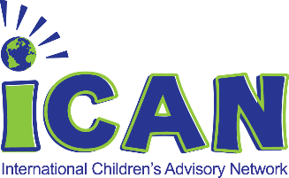

Directions for use:
Please review the lesson plans to gain better understanding on how to direct the following learning activities provided.
Students may complete their learning activities via PowerPoint modules provided for each age group respectively.
Direct students on how you prefer them to use the PowerPoint modules, either in group meetings or by self -study.
At the end of each PowerPoint module, a checklist will be provided listing the activities that the students have completed.
Students will need to mark on the checklist the activities they have completed and provide it to their Group Leaders in order to complete the lesson.
Certificates of completion will be awarded by Group Leaders when the student has completed their lesson plan and has provided proof of the completion by presenting their checklists to their leader.

Tips for Success for Team Leaders:
Remember that most terms within Clinical Research are new to children and youth. Try to avoid using acronyms and if you need help with a definition, share resources such as:
National Institutes of Health (NIH) https://www.nih.gov/health-information/nih-clinical-research-trials-you/basics
Food and Drug Administration (FDA) https://www.fda.gov/regulatory-information/search-fda-guidance-documents/clinical-trials-guidance-documents
World Health Organization (WHO) https://www.who.int/ictrp/child/en/
Stay impartial and be open to answering questions in a factual manner.
Use this reminder as guide – 2020 National Institutes of Health (NIH) (https://www.nih.gov/health-information/nih-clinical-research-trials-you/parents-children)
“Children are not little adults, yet they are often given medicines and treatments that were only tested in adults. There is a lot of evidence that children’s developing brains and bodies can respond to medicines and treatments differently than how adults respond. The way to get the best treatments for children is through research designed specifically for them.” - NIH

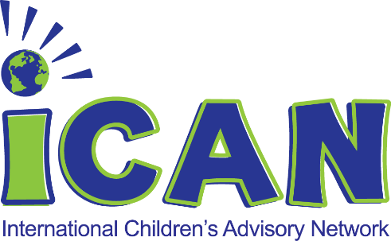
Table of contents
Pre Med Specialist 8-10. Fundamental awareness/basic knowledge…. page 3
Medical Apprentice 10-12. Novice (learning experience)………………… page 4
Clinical Authority 13-15. Intermediate (practical application)………….….page 5
Medical Associate 15-17. Advanced (applied theory)……………………….…page 6
Medical Expert 17+ Expert (recognized authority)………….……………….….page 7
All participants or group activities 8-18……………………………….….…………..page 8

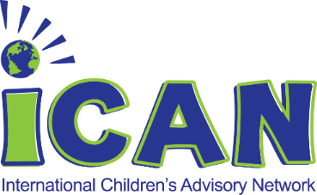

Pre Med Specialist 8-10. Fundamental awareness/basic knowledge

Objective | Content | Activity
To increase self-awareness within the medical field by “Understanding Clinical Research”  - Describe times medicine made you feel better  - Explain the positive attributes of medicine and medical device  - Practice innovation in pediatric healthcare | Encouragement of understanding clinical research and positive self-advocacy to share patient voice  - Provide a positive space for “understanding clinical research”  - Allow assertion of individuality while providing positive encouragement as well as positive reinforcement (CDE, 2000). | Story Time:  - Tell a story about medicine or medical devices that made you feel better.  - Draw a picture of a new medicine and share in your own words how that new medicine might help kids to feel better.
 |  | - Watch iCAN Research Videos to learn more about clinical research and what that means to kids.

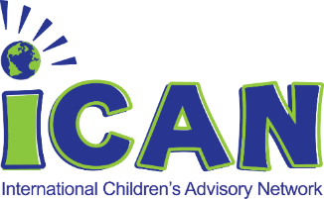

Medical Apprentice 10-12. Novice (learning experience)

Objective | Content | Activity
To increase self-advocacy within the medical field and “Understanding Clinical Research”  - Recognize positive attributes of clinical research  - Identify ways to self-advocate to better understand clinical research  - Practice clinical research terminology  - Promote self- advocacy by learning more about clinical research through the encouragement of asking questions | Encouragement of public speaking and self-advocacy through positive reinforcement and positive message, learning the attributes of those who lead  - Attributes of understanding clinical research:  “The best solutions are the ones with the end-user in mind from the beginning ”- Amy Ohmer  - “Clinical research can not happen without involving children in the beginning”- iCAN Parent  - Within all points of patient advocacy, including clinical research, “Enablement of self-advocacy stems from encouragement of the people to make decisions within their own life, to use their own words, and to be respected as an individual” (Schalock et al, 2002). | Story Telling”  - Using the NIH website https://www.nih.gov/health-information/nih-clinical-research-trials-you/parents-children, research five commonly used clinical research terms and write down definitions.  - Next, take those five words and put them into a story either recorded verbally, written as a paper, or drawn as a series of cartoons.
iCAN Videos:
- Watch NIH Parents and Children video for why Clinical Research is important https://youtu.be/JXoSLynCwgE

- Watch iCAN Research Videos to learn more about clinical research and what that means to kids.

Clinical Authority 13-15 Intermediate (practical application)

Objective | Content | Activity
To increase understanding of clinical research  within the medical field and demonstrating “patient centered” focus.  - Demonstrate understanding of key clinical research terms  - Examine the difference between Assent and Consent  - Practice reviewing Assent and Consent | Encouragement of understanding clinical research is a key aspect of creating patient centered care within medicine  - Researching vocabulary and applying concepts of clinical research help to instill a culture of ensuring patient-centered care by involving the end-user at the beginning.  - Legally, children are not able to give true informed consent until they turn 18. So, before taking part in a clinical trial, they are asked for their assent. Assent  means that they agree to take part. Parents or guardians give informed permission for their child to join the clinical trial. – National Cancer Institute | - Review definition difference between Assent and Consent.  - Review templates of Assent and Consent. https://www.irb.vt.edu/pages/assent.htm
iCAN Video:
- Watch iCAN Research Videos to learn more about clinical research and what that means to kids.

Medical Associate 15-17 Advanced (applied theory)

Objective | Content | Activity
To increase knowledge and understanding of clinical research within pediatric medicine through all phases of development  - Develop a master understanding of common terms  - Practice advocacy for pediatric clinical research projects | Encouragement of mastering the common clinical research term definitions and understanding the process of clinical research builds to create pediatric patient empowerment, advocacy for medicines and medical devices for children and improvement in outcomes by understanding patient needs. | Finish the sentence: “Why does clinical research matter to kids?”  Create a video, draw a comic book, or write a paper to share your ideas.  Be a clinical researcher: “What would I do to help kids understand assent and consent?”  Create an innovative way for kids to better understand assent and consent through the use of video, cartoons, coloring, song, or writing.
iCAN Videos:

- Watch iCAN Research Videos to learn more about clinical research and what that means to kids.

Medical Expert 17+ Expert (recognized authority)

Objective | Content | Activity
To increase knowledge and mastery of understanding clinical research  - Through mastery of understanding clinical research, inform others within the community of the importance of clinical research and involving patient voice at the beginning. | Developing a sense of mastery and knowledge in clinical research so that there is a clear understanding of:  - What is clinical research  - Benefits of clinical research  - Difference between assent and consent  - Commonly used terms and definitions  - Innovation in ways that kids can better understand assent and consent  - How to find opportunities in clinical research (Careers in medicine, science and advocacy) | Research idea: “Pretend you work in clinical research and have an idea to test a new medicine – what is that medicine, how would you set up a clinical research trial and how would you write your assent and consent?”  - Create a video or a written project – use props or drawings to illustrate your new idea.
 |  | Review iCAN Videos to better understand what clinical research is and what it means to kids.

All participants or group activities 8-18

Objective | Content | Activity
- To increase self-awareness of understanding clinical research and to become an advocate for clinical research projects that support medicines and medical technology for kids by being patient-centered, with a goal of improving patient outcomes around the world. | Encouragement of hands on involvement in learning more about clinical research through a series of discussion, hands on activities and involvement of clinical researchers within the community. | Meet a Clinical Researcher:  Invite a clinical researcher from your local children’s hospital to come and share ideas about their efforts to create clinical research for pediatric medicine and medical devices.
Practice being a Clinical Researcher:
Assign roles of clinical research to each youth member (patient, parent, researcher) and have them act out parts. Encourage discussion using key terms and definitions, plus review of mock assent and consent.
Lead positively:
Choose a case study and review with your youth members. Ask what they would do differently to make it easier for kids to participate.

Guess who I am:
Play a game in which roles of clinical research are assigned to various members and ask the group to say who they are. This can include all parts of the team, including providers, researchers, nurses, patients, parents, and more. Be creative and have fun!

